**Lab 1. Data Query Language**

**Q1. Retrieve the details (Name, Salary and dept code) of the employees who are**

**working in department 20, 30 and 40.**

SELECT ENAME,SAL,DEPTNO FROM EMP WHERE DEPTNO IN (20,30,40);

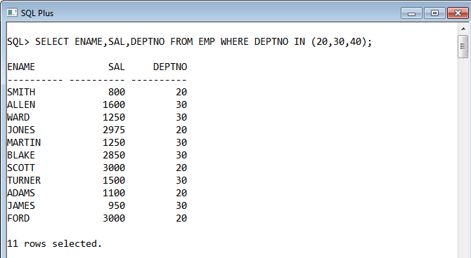

**Q2. List the details of the employees with user defined Column headers.**

SELECT EMPNO AS EMPLOYEE_CODE, ENAME AS EMPLOYEE_NAME,SAL AS EMPLOYEE_SALARY,DEPTNO AS EMPLOYEE_DEPARTMENT_CODE FROM EMP;

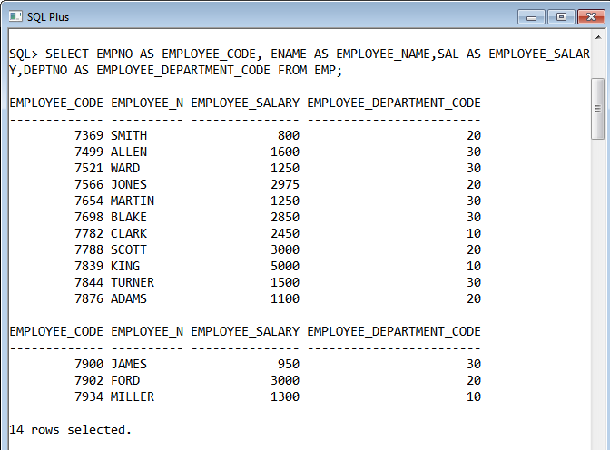

**Q3. Display the code, subjects and total marks for every student. Total Marks will be**

**calculated as Subject1+Subject2+Subject3. (Refer Student_Marks table)**

SELECT STUDENT_CODE,STUDENT_YEAR,SUBJECT1, SUBJECT2,SUBJECT3,SUBJECT1+SUBJECT2+SUBJECT3 AS TOTAL FROM STUDENT_MARKS;

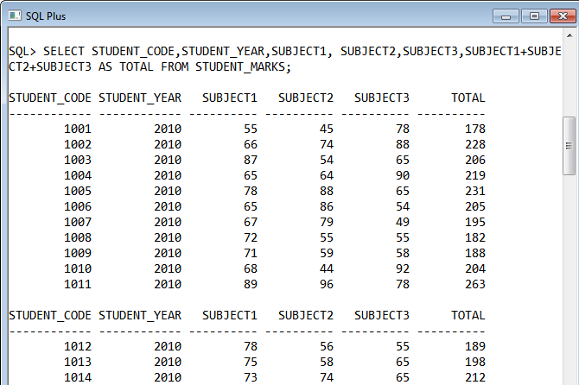

**Q4. List the details of the staff whose designations are either PROFESSOR or** **LECTURER.**

SELECT * FROM STAFF_MASTER WHERE DESIGN_CODE IN (SELECT DESIGN_CODE FROM DESIGNATION_MASTER WHERE DESIGN_NAME IN ('LECTURER','PROFESSOR '));

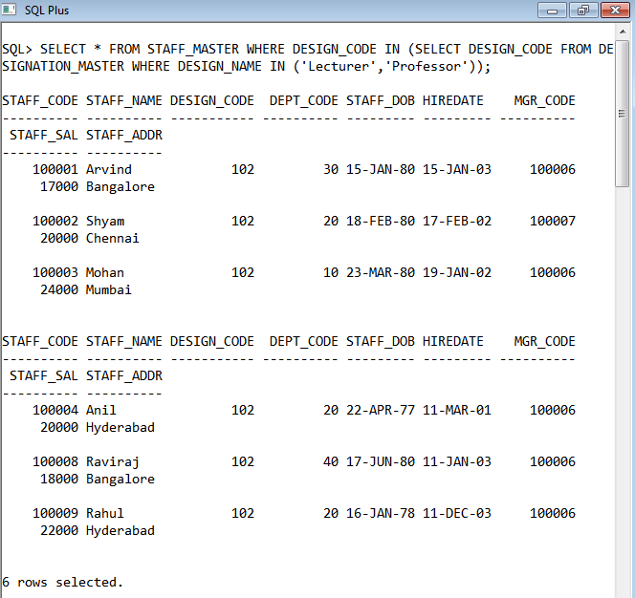

**Q5. List the code, name, and department number of the employees who have experience of more than 18 years.**

SELECT EMPNO,ENAME,DEPTNO FROM EMP WHERE ABS(MONTHS_BETWEEN(HIREDATE,SYSDATE)/12) >18;

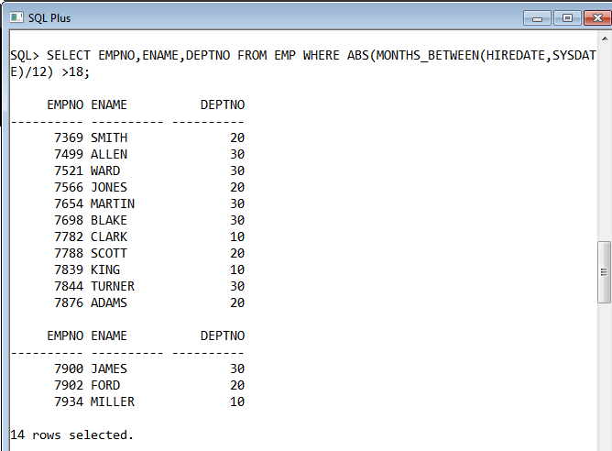

**Q6. List the name and Designations of the staff who have joined before Jan 2003.**

SELECT STAFF_NAME,DESIGN_CODE FROM STAFF_MASTER WHERE SUBSTR(TO_CHAR (HIREDATE,'DD/MM/YYYY'),4,10) > '01/2003';

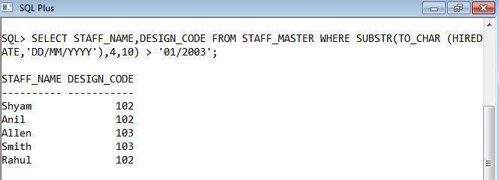

**Q7. List the name, designation, and income for 10 years of the employees who are working in departments 10 and 30.**

SELECT ENAME,JOB,SAL*10 AS INCOME FROM EMP WHERE DEPTNO IN (10,30);

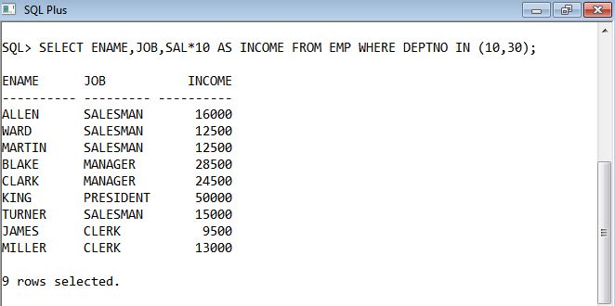

**Q8. List the name and experience (in years) of employees who are working as LECTURER.**

SELECT STAFF_NAME,ROUND(ABS(MONTHS_BETWEEN(HIREDATE,SYSDATE)/12)) AS EXPERIENCE FROM STAFF_MASTER WHERE DESIGN_CODE IN (SELECT DESIGN_CODE FROM DESIGNATION_MASTER WHERE UPPER(DESIGN_NAME)='LECTURER');

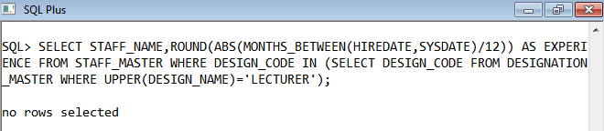

**Q9. Display name concatenated with dept code separated by comma and space. Name**

**the column as ‘Student Info’.**

SELECT STUDENT_NAME||', '||DEPT_CODE AS "STUDENT INFO" FROM STUDENT_MASTER;

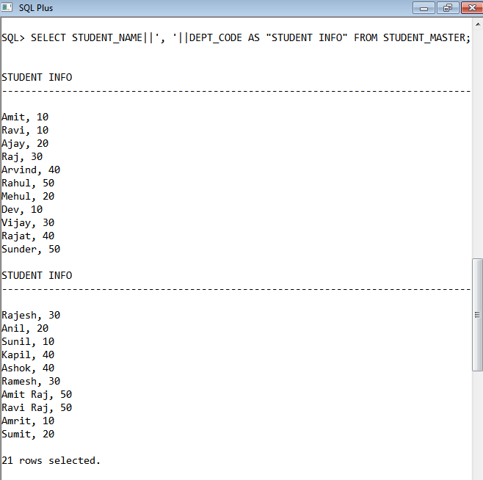

**Q10. List the Name and Salary of the staff who are earning between 12000 and 25000.**

**Sort them based on their salaries and name.**

SELECT STAFF_NAME,STAFF_SAL FROM STAFF_MASTER WHERE STAFF_SAL BETWEEN 12000 AND 25000 ORDER BY STAFF_SAL,STAFF_NAME;

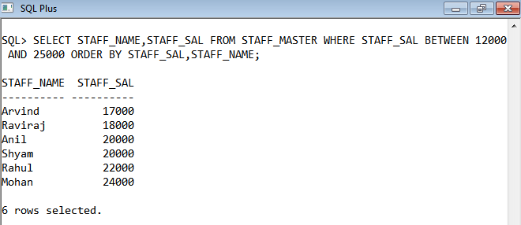

**Q11. Display employees who do not have manager.**

SELECT * FROM EMP WHERE MGR IS NULL;

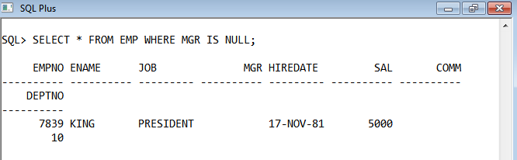

**Q12. Write a query which will display name, department code and date of birth of all**

**students who were born between January 1, 1981 and March 31, 1983. Sort it based**

**on date of birth (ascending).**

SELECT STUDENT_NAME,DEPT_CODE,STUDENT_DOB FROM STUDENT_MASTER WHERE STUDENT_DOB BETWEEN '01-JAN-1981' AND '31-MAR-1983' ORDER BY STUDENT_DOB ASC;

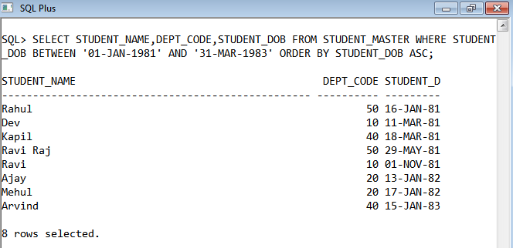

**Q13. Get the Department number, and sum of Salary of all non managers where the**

**sum is greater than 20000.**

SELECT DEPTNO,SUM(SAL) AS SALARY FROM EMP WHERE JOB!='MANAGER' HAVING SUM(SAL)>2000 GROUP BY DEPTNO,SAL;

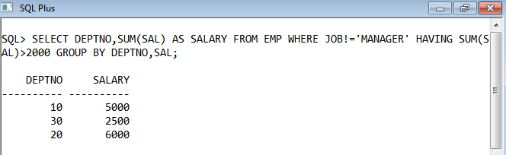

**Q14. Display the details of books that have not been returned and expected return date**

**was last Monday.**

SELECT * FROM BOOK_TRANSACTIONS WHERE BOOK_ACTUAL_RETURN_DATE IS NULL AND TRIM(UPPER(TO_CHAR(BOOK_EXPECTED_RETURN_DATE,'DAY')))='MONDAY';

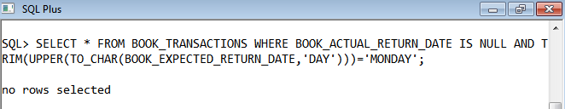

**Q15. Display the name and department code of students. If student does not belong to**

**any department, display “No Department”. Label the column as “Department”. (Hint:**

**Use NVL function)**

SELECT STUDENT_NAME,NVL(TO_CHAR(DEPT_CODE),'NO DEPARTMENT') AS "DEPARTMENT" FROM STUDENT_MASTER;

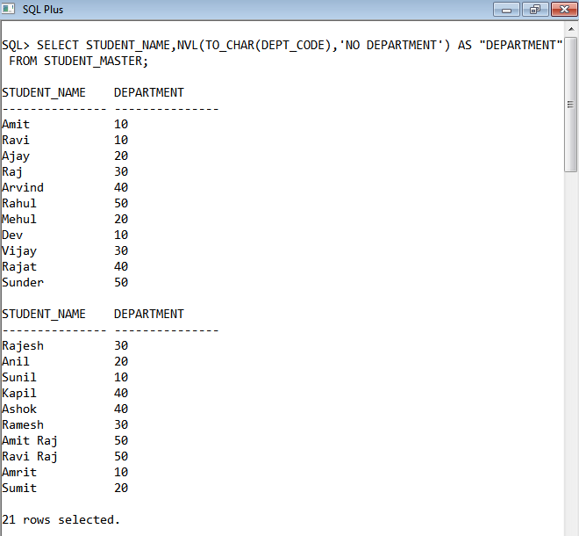

**Q16. Display the name and salary of the staff. Salary should be represented as X. Each**

**X represents a 1000 in salary.**

**Sample Output**

**JOHN 10000 XXXXXXXXXX**

**ALLEN 12000 XXXXXXXXXXXX**

SELECT STAFF_NAME,RPAD('X',STAFF_SAL/1000,'X') AS SALARY FROM STAFF_MASTER;

